

***TECHNOCRATS***

***ROBOTICS***

02/09/2018

Inventory List for Mechanical Department

|  |  |
| --- | --- |
| Item | Quantity/Sizes |
|  |  |
| Drill-Bits | Sizes 3,4,6,7,8,10 |
| Castor Wheels | 6 |
| Spanners | All required sizes |
| Grease (Packets) | 2 |
| Pillow Blocks | 3 |
| Machine Screws | Sizes 3,4,5,6 |
| Resin (Bottles) | 3 |
| Resin Hardener (Bottles) | 3 |
| Cutting Blades | - |
| Measuring Tapes | 3 |
| Doctor’s Tape | 1 |
| Teflon Tape | 1 |
| Bosch Kit | 1 |
| Welding Apparatus : Collet body | - |
| Welding Apparatus : Collet cup | - |
| Gear box | - |
| Cutting Machine | 1 |
| Drilling Machine | 1 |
| Pliers | 2 |
| Nose Plier | 1 |
| Rotor Blades | - |
| Hammer | 1 |
| Screwdrivers | - |
| Rack (Gear) | - |
| Washers | - |
| Filer | 1 |
| Drafter | 1 |
| Wheels: Omni Wheels | 7 |
| Wheels: DC Motor Wheels | - |
| Wheels: Small Wheels | 6 |
| Bearings | - |
| Bearings w/ Nylon Shaft | 1 |
| Lock Nuts | - |
| Nails | - |
| M-Seal | Half |
| Saw | 1 |
| C-Clamps | - |
| L-Clamps | - |
| Hose Clamps | - |
| Hinges | - |
| Pressure Gauge | 1 |
| Paper Clips | - |
| Dummy Motor Mount | 1 |
| Linear Actuator Mount | 1 |
| Tachometer | 1 |

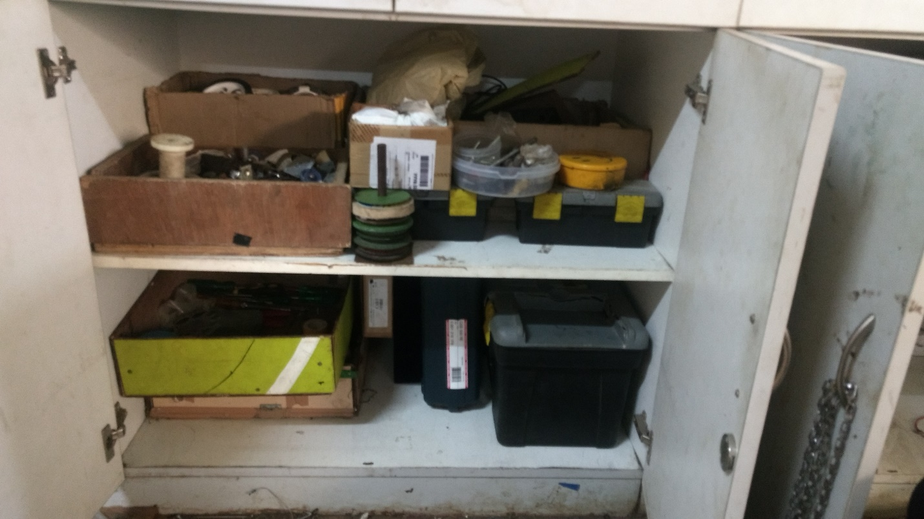

Mechanical Inventory as on 02/09/2017